Target Camera
(Name Pending)
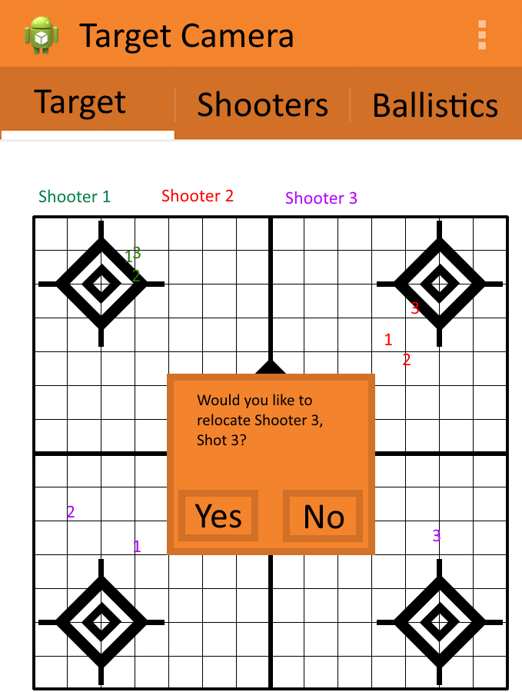
Representation of selected functions

Abstract
An Android/IOS app to facilitate comprehensive and, above all else, simple tracking of firearm shots on any given target at any given range with user options available for selection of ballistics and multiple shooters to facilitate easy sight-in by providing near-instant feedback on groups, distance from point of aim, and progression.
Contents
Cover

Targeted audience

Logical arrangement of options/settings

Versioning (and levels of features based on purchase)

Potential permanent installation

Description of each function/feature

Other camera devices

Competing products
Notes

All text highlighted in yellow is undecided.
Targeted Audience

Hunters, firearm enthusiasts, firearms competitors, amateur shooters, recreational shooters

The simplicity of the program will appeal to the hunter who sights in his/her rifle once a year before hunting season, while the available comprehensiveness will be useful to the competition shooter who reloads his/her own rounds.

Law enforcement/military will benefit with quicker range exercises, detailed digital reports on individual shooters (suitable for records jackets) and computer-controlled range exercises.

Logical arrangement of options/settings

Ideas
- Scenarios based on audio/video (Ryan)
- Recognize specific targets (i.e. Battleship targets) to enable competition (Michael)

Features
- Target
- Mode
- Orientation
- Social Media Integration
- Ballistics
- Shooters
- Equipment
- Permanent installation

Top bar
- Settings
  - Mode
    - Bench
      - Master
        - Connections
        - Target image command
      - Observer
        - Connections
    - Downrange
      - Connections
  - Simple
    - Target
    - Mode
    - Orientation
  - Advanced
    - Ballistics
    - Multiple Shooters
    - Equipment
- Save/Share
  - Data
  - Scenario
- Load Scenario
  - Saved scenarios or pre-loaded competitions
    - Provided by us or user-developed?

Target
- Display target
- Number shots
- Indicate shooter
- Provide options for logically relocating shots
- Switch current shooter

Ballistics
- Select Caliber
- Select bullet weight
- Select powder load and type
- Select per-defined Manufactured load
- Select range to target
- Select desired range for Zero

Shooters
- Select multiple numbers of shooters (maximum?)
- Define name
- Select shooter color

Equipment
- Scope brand/model
  - Advise number of clicks for required adjustments
- Iron/Open sights
  - Advise sight adjustments

Orientation
- Enable Keyhole correction
  - Select corners of target
  - Select dimensions to use (SI or American)
  - Define physical target dimensions
  - Select multiple bulls-eyes
- Define score regions

Social Media Integration
- Option available on top bar from any point of the program

Mode
- Bench
  - Master
    - (User option) request target image
    - Receive target image
    - Apply keyhole correction
    - Identify shots
      - Edit shots out of picture based on original image
      - Label shots according to shooter, number of shots
      - Calculate physical distance from desired bulls-eye
        - Allow relocation (i.e. user aimed at wrong bulls-eye)
      - Store all data in table
    - Configure all settings
    - Allows all features
    - Allows Observers
    - Sends final target images to any Observers
  - Observer
    - Allows Target feature only
- Downrange
  - (No computation to allow for other image-taking devices)
  - Controlled by Master
  - Listen for signal from Bench Master
  - Take picture of target
  - Send image to Bench Master

Permanent Installation
- Connect to range network
- Operate as Bench Master

Versioning
(and levels of features based on purchase)

Basic version will have only the Simple featureset: Target, Mode, Orientation
~$4.99

Full version will have the Advanced featureset: Simple featureset plus Ballistics, Multiple Shooters, Equipment
~$10.99 (on top of Basic price, or total price?)

Monthly contract will be available for permanent installations with option to host all data services in the Cloud. More advanced shooting scenarios will be available, and more detailed reports on shooting scores, progression, etc.

Bench modes will be free to use for all; charging enables Downrange mode (this allows a shooter to bring friends to the range without requiring additional purchases, also allows the shooter his/her own monitoring device).
Permanent installation

This system can also be used in permanent installations. Either the range can provide monitors, or require users to supply their own device to monitor, or option for both. The range can store this information themselves, or have it hosted (by us or a shooting sports association) for centralized digital recordkeeping.

Range setup will be as simple as bowling alleys: a shooter is assigned a lane and connects his/her device to the range's network, setting which lane they are in, facilitating communication with his/her specific downrange camera. Since the device is running in Bench mode, there is no additional charge for the shooter. The shooter will be in Bench Observer mode, and all configuration is either already set on the server or configurable per lane (shooters, etc.).

Description of each Function/Feature

Top bar
- Settings
  - Mode
    - Bench
    - Downrange
  - Simple
  - Advanced
- Save/Share
- Load Scenario

Mode allows for selection of Bench and Downrange modes, and will then handle communication settings.

Simple mode is our most basic feature set. It allows only a single shooter, no ballistics entry, no equipment entry, and no Bench Observers. The only function of this mode is basic target pictures, and numbering of shots; no calculation of shot location or desired sight-in.

Our basic release will incorporate ONLY Simple mode.

Advanced mode will make available the full feature set including ballistics, multiple shooters, equipment selection, and shooting scenarios. It will also enable calculating shot placement and setting desired sight-in range.

Save/share will utilize Google's Sharing feature, allowing the user to save locally, e-mail, save to Dropbox, etc. Users can save scenarios or just shot data. Shot data will consist of the final {keystone-corrected) target, shooters, and coordinates of each shot.

Load will load a scenario for scenario-based shooting activities.

I kind of want more modes, perhaps a Simple, Advanced, and Competition to further divide the program and allow for increased functionality.

Target
- Display target
- Number shots
- Indicate shooter
- Provide options for logically relocating shots
- Switch current shooter

Available to all Bench devices.
This screen will be the default viewing screen, and the only screen available to Bench Observers (with reduced functionality). It will display the target and each shot, numbered and color-coordinated to each named shooter. The active shooter's name will be highlighted, and changing shooters can be done by simply tapping the shooter's name. If a shooter shoots at the wrong bulls-eye of the target, the Bench Master simply selects the option to Relocate Last Shot.

A button to manually capture the target image will always be available on the Bench Master.

Selecting shooter, relocating shots, and requesting target image can only be done by the Bench Master.

All viewers will be able to select a shot and view physical data in traditional (x, y) coordinates in the units specified in Orientation.

Ballistics
- Select Caliber
- Select bullet weight
- Select powder load and type
- Select pre-defined Manufactured load
- Select range to target
- Select desired range for Zero

Only available to Bench Master
The Ballistics screen provides options for selecting pre-defined (per manufacturer) loads, or defining custom loads by specifying caliber, bullet weight and type, powder weight and type, and barrel length. Using these, ballistics can be calibrated within a reasonable margin (hopefully, if not, portions of this feature may need to be eliminated). Entering in sight-in range and actual target range can calculate where the shooter needs to hit on the target (while aiming at the bulls-eye) to hit the bulls-eye at the desired range.

Ballistics can be set for each shooter.

Shooters
- Select multiple numbers of shooters (maximum?)
- Define name
- Select shooter color

Only available to Bench Master.
The Shooters screen allows assigning shooters by inputting names and selecting a color for that shooter's shots to be represented by. Shooters can be added at any time. Is removing a shooter available?

Equipment
- Scope brand/model
- Iron/Open sights

Only available to Bench Master.
Equipment selection will allow selecting an aiming method: open sights, scope, etc.

Do we maintain a database of sights/scopes or do we simply allow the user to input how his/her sights/scope work (i.e. 1 click for 1” at 100yds, 1/4 turn for 1” at 100yds, etc.) or both?

Orientation
- Enable Keyhole correction
  - Select corners of target
  - Select dimensions to use (SI or American)
  - Define physical target dimensions
  - Select multiple bulls-eyes
- Define score regions

Only available to Bench Master.
Orientation allows the user to input the target dimensions in inches or centimeters, and then identify the corners of the target. The device can then rectify the image based on keystone geometry. In Advanced mode, the user can also specify multiple bulls-eyes and scoring regions.

Orientation can automate itself based on target recognition, and certain “known” pre-loaded targets can be used.

Mode
- Bench
  - Master
    - (User option) request target image
    - Receive target image
    - Apply keyhole correction
    - Identify shots
      - Edit shots out of picture based on original image
      - Label shots according to shooter, number of shots
      - Calculate physical distance from desired bulls-eye
      - Store all data in table
    - Configure all settings
    - Allows all features
    - Allows Observers
    - Sends final target images to any Observers
  - Observer
    - Allows Target feature only
- Downrange
  - (No computation to allow for other image-taking devices)
  - Controlled by Master
  - Listen for signal from Bench Master
  - Take picture of target
  - Send image to Bench Master

The full system will consist of two devices, Downrange and Bench (Master). There can additionally be a third (or fourth...) that acts in a reduced Bench mode called Bench Observer (see below).

Downrange mode will receive the command to take a picture, take a picture, and send it back to the Bench Master. Limiting Downrange mode to only these processes allows potential incorporation of other devices for picture-taking. The goal is to allow any wifi-enabled camera device (wifi cameras, GoPro, etc.) that can receive commands to act as the downrange device.

Bench Master will set up the communications. The BM can set a password to limit Bench Observers (BO's). Bench Master has access to all settings available based on either the Simple or Advanced featureset. Bench Master can automatically request target images based on pre—set sounds: gunshot, whistle, verbal command, etc.

BM will calculate the image location, and store the information in a table which can be saved/sent via the Top Menu. BM will also send the target image to all Bench Observers.

Bench Observer connects to Bench Master and can only receive the last updated target image, sent by the BM. This allows the BM to be placed directly in front of the shooter, so the shooter does not have to leave his/her shooting position, while enabling a shooting coach or partner to also view shot location.
Other Camera Devices

Support for ANY camera that can accept a command, take a picture, and transmit the picture back to the requesting device.

GoPro?
WiFi enabled point-n-shoot cameras?
Kinect?
Competing products

Bullseye Camera:
http://www.bullseyecamera.com/

Expensive, MOST of the functionality we will embrace. It does not apply keystone correction to the image, and it does not appear to automatically label shots nor shooters. Shooters must manually select and label shots.

Bulky; requires additional charger, carrying extra equipment to the range.

This is probably our biggest and most direct competition.

Target Vision
http://targetvisioncam.com/

Expensive, appears to be just long-range wireless spotting scopes and automatic target changing.

Bulky; requires additional charger, carrying extra equipment to the range.

TargetCam
http://www.targetcam.net/

Expensive; not many features shown

Bulky; requires additional charger, carrying extra equipment to the range.

Homemade
http://www.6mmbr.com/targetcam.html

Expensive; very technical, must be able to cobble own equipment together.

Bulky; requires additional charger, carrying extra equipment to the range.

